**Individual assignment 4-- Google Analytics**

**Eric Agyemang**

The goal of this lab practice is to try Google Analytics a little bit and to learn what insights you can gain from it.

1. Read “The Absolute Beginner's Guide to Google Analytics”. <https://moz.com/blog/absolute-beginners-guide-to-google-analytics>

If you have a website, you can try to track it with the tracking scripts. If not, use the demo account in your Google Analytics account.

2. Information about the demo account can be found here <https://support.google.com/analytics/answer/6367342?hl=en>

Click this link <https://analytics.google.com/analytics/web/demoAccount> to add the demo account to your Google Analytics:

Click Universal Analytics property: Google Merchandise Store (web data) on the page

The data in the Google Analytics demo account is from the Google Merchandise Store, a real e-commerce store <https://shop.googlemerchandisestore.com/>

3. Watch the “Google Analytics Beginners Tutorial” <https://www.youtube.com/watch?v=njri8_gJTs0&t=0s>

4. Take screenshots and answer the following questions. Submit your answers to Reggienet by 10/5.

Use the following time frame for all the answers

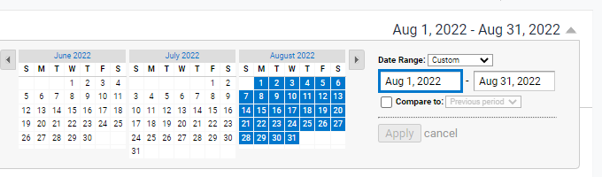

1. How many people have visited the website in Aug. 2022?

**Answer:** 58,674 visited the website

1. Where do the visitors live?

**Answer:** Countries where they live are shown in the screenshots below.

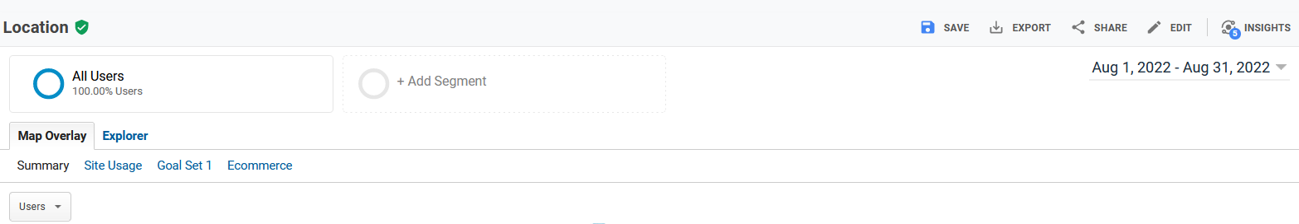

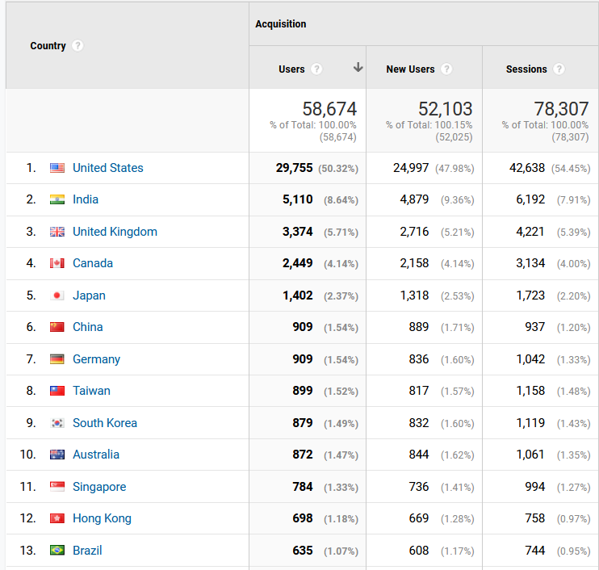

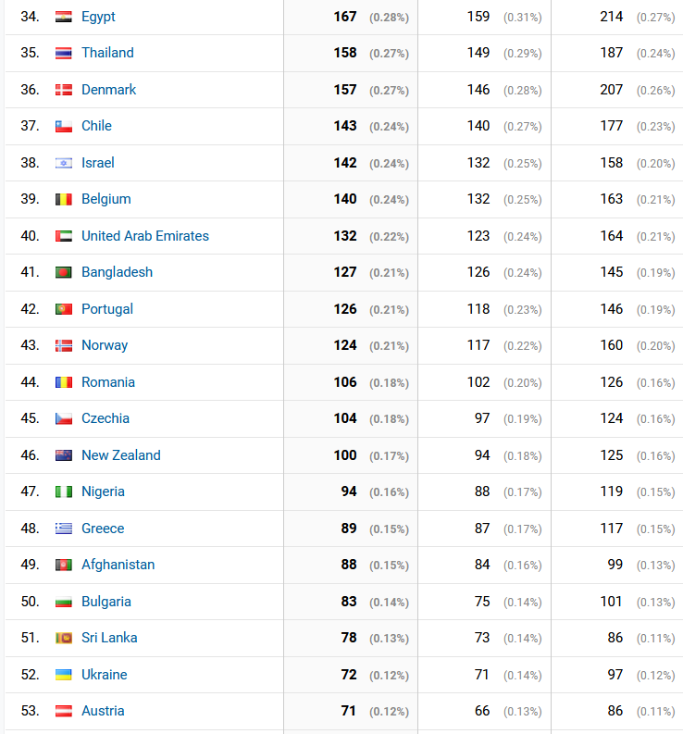

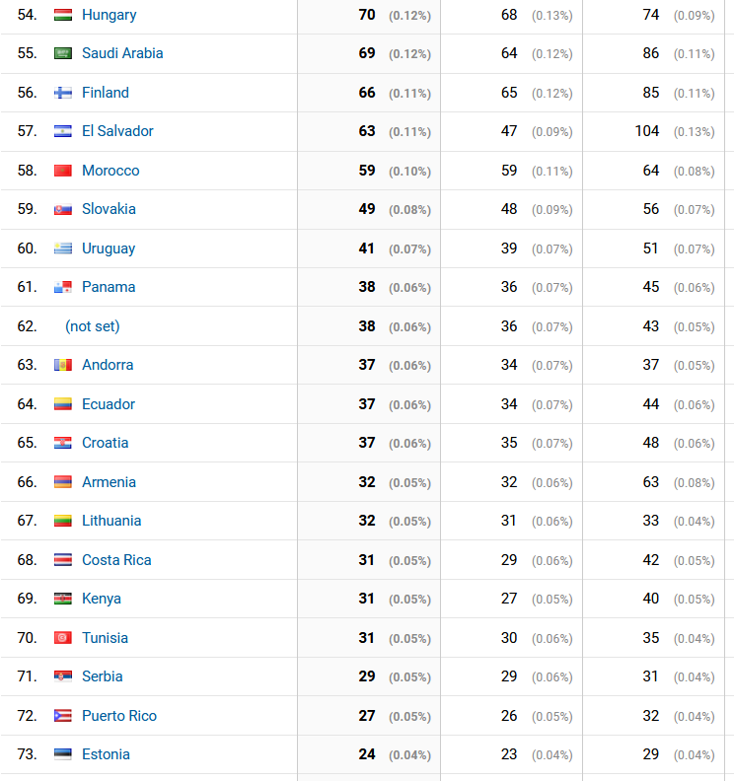

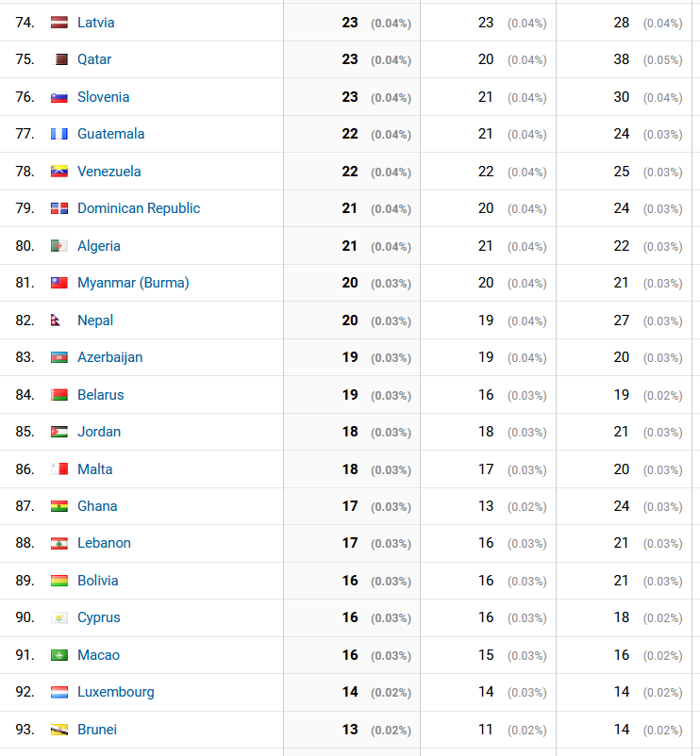

1. Do they need a mobile-friendly website? (Hint: find out how many users use mobile phones)

**Answer:**

18,022 users use mobile phones as indicated on the screenshot below. This is about 30.72% of the 58674 total uses. This is considerably high percentage of total users, so I suggest users need mobile-friendly website. More users may be attracted to visit the website using their mobile phones if there is an easily accessible, and mobile-friendly website available for them. This may lead to increase in number of customers.

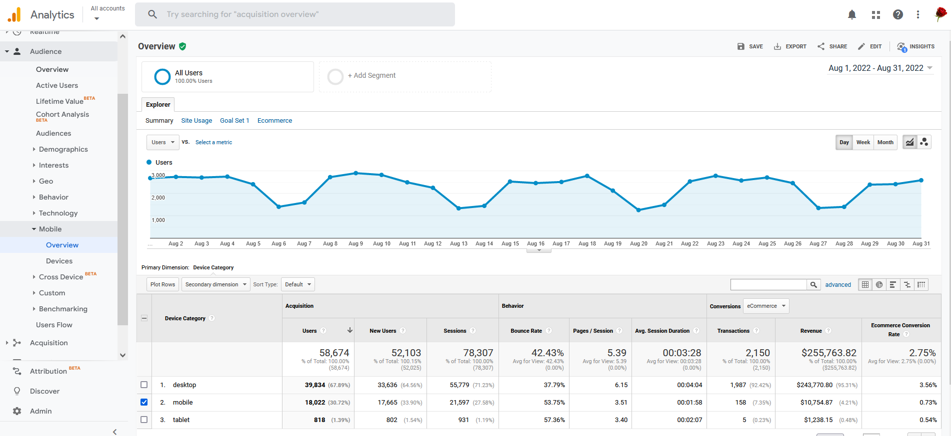

1. What Channels send traffic to the website?

**Answer:** Traffic is coming from direct, partners, and google as shown below.

1. What are the most popular products?

They include Google Crewneck Sweatshirt Black, Google Unisex Eco Tee Black, Google MiiR 15L Backpack, Google RIPL Ocean Blue Bottle, up to Google Marine Layer Navy Tee from the screenshot within the month of August.

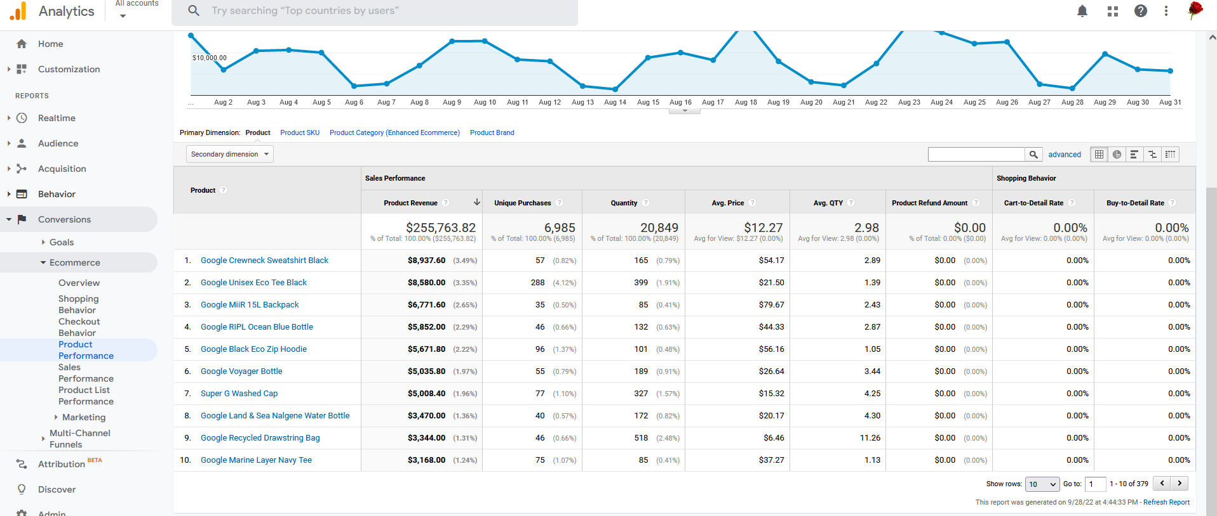

1. Which pages on the website are the most popular?

**Answer:** Ten most popular pages are listed on the screenshot below with their total pageviews and their percentages of views.

1. What is the “Goal Conversion Rate” number?

**Answer:** The Goal Conversion Rate is 25.23% and the Goal value is $0.00

1. Which age group has more users? 25-34 or 18-24?

Answer: 25-34 has more users. It constitutes 8,521 users which represents 33.62% of all users, while 18-24 constitutes 7,217 users which represents 28.475% of all users.

1. What is their average page load time?Graphical user interface, application

   Description automatically generated
2. What does the users’ behavior flow look like?

Answer: It looks like a waterfall model where each iteration phase depends on the deliverables of thew previous one and corresponds to a specialization of tasks

